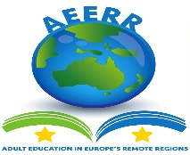

ADULT EDUCATION IN REMOTE REGIONS

The project focuses on peripheral regions of the EU, and aims at identifying and analysing the specific opportunities and the difficulties linked to their geographical position, especially in the field of EU integration, the different aspects of education in remote regions, the specific needs to ensure the actual implementation of EU inclusive policy, the efforts needed to better integrate those regions into EU policies and programmes.
The previous KA1 project was a big success for IHF, resulting in a very positive impact on the organisation and on its staff, but also in the development of two projects funded in the frame of Erasmus Plus 2018 KA2 with new partners from Iceland and Martinique.
The KA1 project was highly beneficial for IHF, in terms of development, upgrade and improvement of its internal organisation as well as external activities, further strengthen by the raise of motivation, competences and awareness of IHF staff. The current project stems from this experience: through this project the staff of IHF will further improve their organizational, training and multicultural skills and competences, resulting in professional development for the participating staff, and in concrete improvement of the organisation in terms of increased capacity to operate at EU level.

Project ref: 18MA0002
STARTING DATE DECEMBER 1, 2018 – END DATE NOVEMBRE 30, 2020

